Project Development Phase
Model Performance Test

Date | 28 September 2026
Team ID | 6ab221341
Project Name | Implement Client Scripts & UI Policy (Incident)
Maximum Marks | 10 Marks

Model Performance Testing:
Project team shall fill the following information in model performance testing template.
S.No | Parameter | Values | Screenshot
- 1 | Client Script Testing | Client Script validates incident input and performs dynamic field actions correctly. | 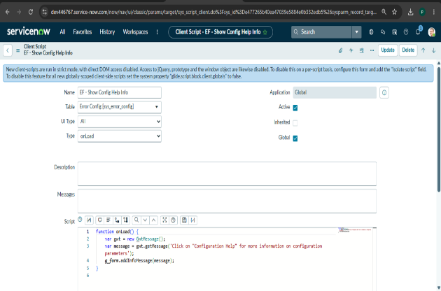
- 2 | UI Policy Testing | UI Policy correctly controls field visibility, mandatory status and read-only behaviour. | 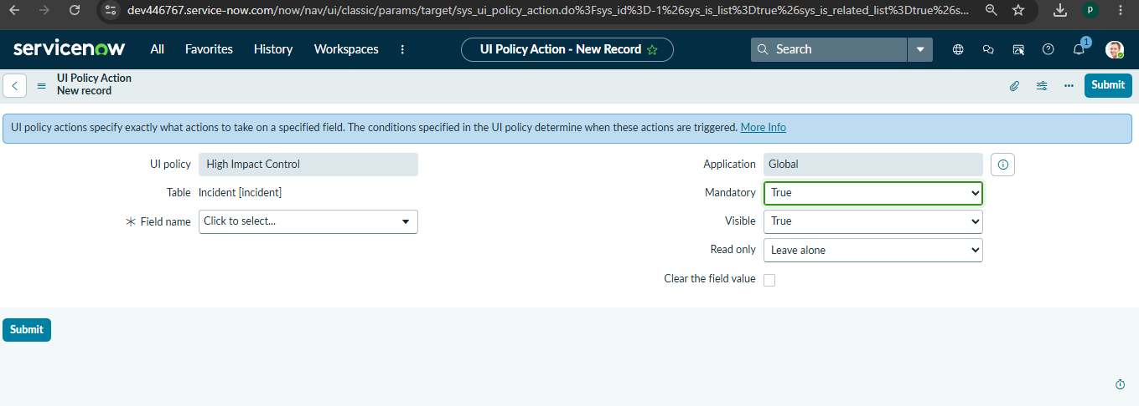
 |  | Incident form accepts valid details and saves the incident successfully. | 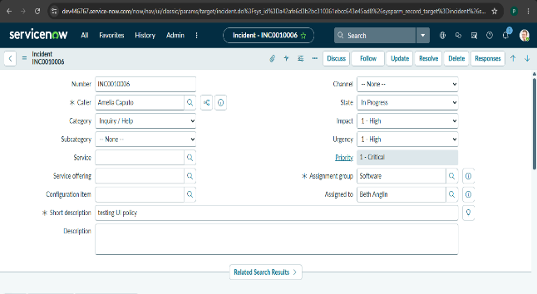
  Incident Form Testing

